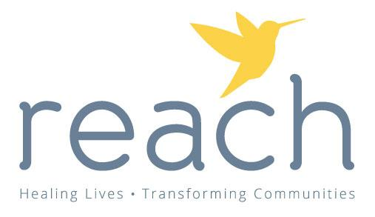
Volunteer Application
Last Name: ___________________________________ First Name:_______________________________ MI:________
Maiden/Previous Name: ____________________________________ Date of Birth (mm/dd/yyyy): __________________
Address: ___________________________________________________________________________________________
City:_____________________________ State: _______________________ Zip Code:__________________
Phone number: ________________________________ On Call Phone Number (if different): ______________________
May we leave a message: Yes No Email Address: ____________________________________________________
Education/Training:
High school diploma: Yes No Year of Graduation:
College/Vocational Degree: Yes No Year of Graduation:
Major: Minor:
Employment:
Are you currently employed? Yes No Where? _______________________
Are you an employee of UW Oshkosh? Yes* No
What are your typical hours? ____________________________
Volunteer Activities:
How did you hear about volunteer opportunities at Reach Counseling?

List any previous volunteer experience:
Agency Dates of Service
_____________________________________ ______________________________
_____________________________________ ______________________________
_____________________________________ ______________________________
Please identify any special skills or talents you have which may enhance what you can offer us as a volunteer: (examples may be fundraising experience, experience facilitating groups, working with children, public speaking, experience working with diverse populations, proficiency speaking another language).

Please list any limitations which may limit your ability to perform certain tasks:

What are you interested in doing? (See descriptions on last page)
__ After Hours Advocate __Latinx Advocacy __ Information Tables
__ Special Events __ Office Assistant __Donation Drive Help
__ Prevention Education __ Other (please specify):

Personal Insight and Feelings:
Why are you interested in volunteering for Reach Counseling Services?

What does sexual violence mean to you?

Why does sexual violence happen?

What does crisis mean to you?

What do you do for self care?

Have you been personally affected by sexual violence (this can include yourself or someone close to you)? If so, when did the assault occur? What have you done to heal, and how do you feel hearing others’ stories of sexual violence will impact you?

References (please list 2):

_____________________________________________________________________________________
Name Relationship Phone

_____________________________________________________________________________________
Name Relationship Phone

With my signature, I am authorizing Reach Counseling Services to investigate any information contained on this application.
Signature _________________________________________________ Date ______________

Please complete the attached Background Check form and return to Volunteer Coordinator with application.

Volunteer Positions
After Hours Advocate
Volunteer Advocates are trained to provide emotional support, crisis intervention, information and resources to survivors of sexual abuse and assault in Winnebago County. Advocates provide these services over the phone or in person at a local hospital. Advocates work alongside medical and legal professionals to ensure survivors are supported while navigating these processes, reducing further trauma and re-victimization while tending to a survivor’s emotional needs. Advocates will work with nurses and law enforcement to provide wrap-around, compassionate care while a survivor receives a forensic exam and/or gives a statement to the police.
Office Assistant
Our volunteers help with coverage of the front desk, filing paperwork, office organization, and other tasks to help our staff move smoothly through our workdays.
Prevention Education
Our Prevention Education program is active in 71 schools in Winnebago County. We have a K-12 curriculum for sexual violence to educate about and prevent child abuse in our community. Volunteer Presenters will be trained in each grade level and will present within the schools. Additional training will be provided to answer questions from the students and respond if they disclose sexual abuse.
Thank you for your interest in volunteering with Reach Counseling Services. If you have any questions or would like more information, please contact us!
Kylene Spanbauer, Volunteer Coordinator & Community Outreach Manager
920-722-8150 // 920-385-9814
kylene@reachcounseling.com or volunteering@reachcounseling.com

1509 S. Commercial St., Neenah, WI 54956
400 N Richmond St. Suite F, Appleton, WI, 54911

